# How to Run the Campus Classic Simulations.

You can run this as a measure within the OpenStudio Model Editor, but you can also run it via the console, or through NetBeans.

## Downloading the code.

Use tortoise Git to ‘clone’ the Phylroy branch of the Prototype repository. From here https://github.com/phylroy/OpenStudio-Prototype-Buildings.git

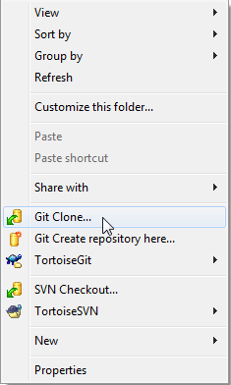 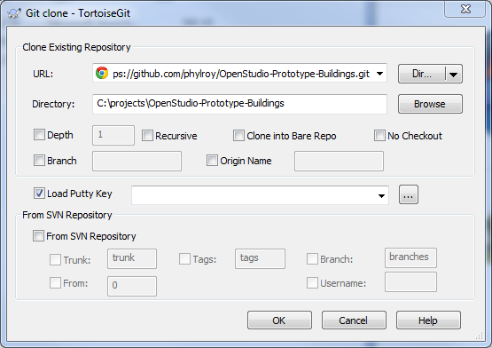

Clone it to a disk that has a LOT of free space. 200GB+

## The Command Line way.

If you are not interested in development of scripts, and just want to edit the xlsx files.. This is for you.

### Set up your environment.

1. Install OpenStudio 1.8+
2. Add C:\Program Files\OpenStudio 1.8.0\ruby-install\ruby\bin\; to the start of the PATH environment variable. (The path may be different depending on the version of OpenStudio you have. If you upgrade OpenStudio, you will have to update your path)

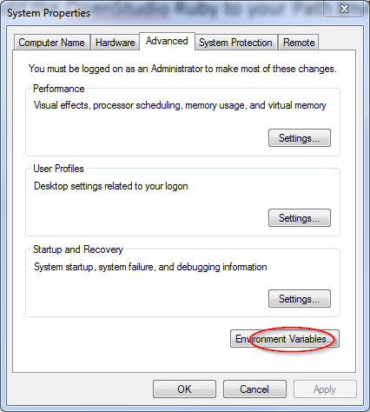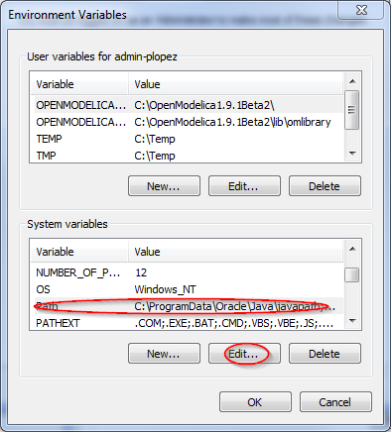

### Running the Simulations

1. Go to this path relative to the root of your cloned repository using windows explorer.

OpenStudio-Prototype-Buildings\lib\btap\measures\btap_campus_classic

1. Expand the xlxs data contained in the Excel file to csv file by running the PowerShell script on XLS2csv.ps1

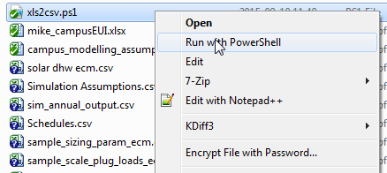

1. Go to the ‘test’ folder and open a command line window. A quick way to do this is to type cmd in the path of Windows Explorer and hit enter.

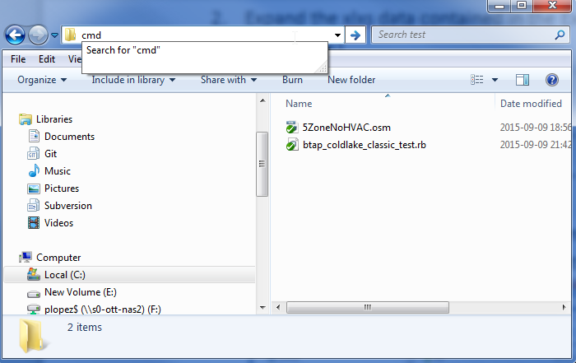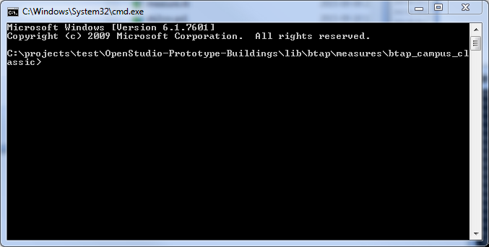

Enter the command :

ruby btap_cold_lake_classic_test.rb

Now you should see things start. Depending on your computer this may take hours..or days. After all the files are created, it will start running them.. You should see this pop up in an hour or less. All output is contained in the output folder.

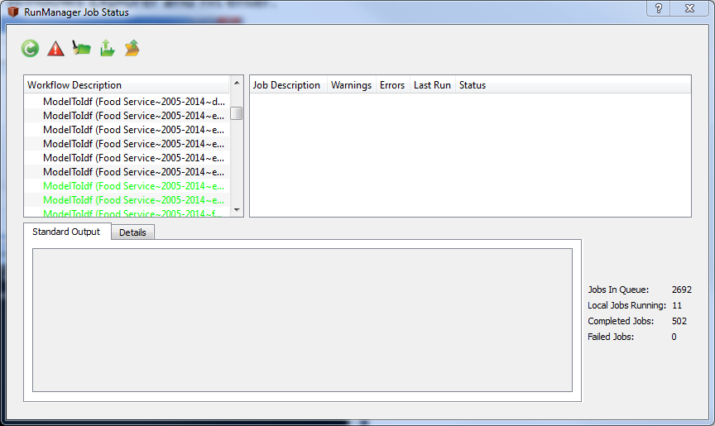

## The Netbeans Way.

### Installation of NetBeans.

1. Install Netbeans from here. <https://netbeans.org/downloads/> Any version will do. I recommend the Java SE for it’s small size.
2. Download the Ruby plug-in from here. <http://plugins.netbeans.org/plugin/38549> and unzip somewhere.
3. Start Netbeans and go to Tools->Plugins and to the Download Tab. Hit the “Add Plugins” button and navigate to where you unzipped the files.
4. Select all the nbm and jar files and click open and follow the prompts. 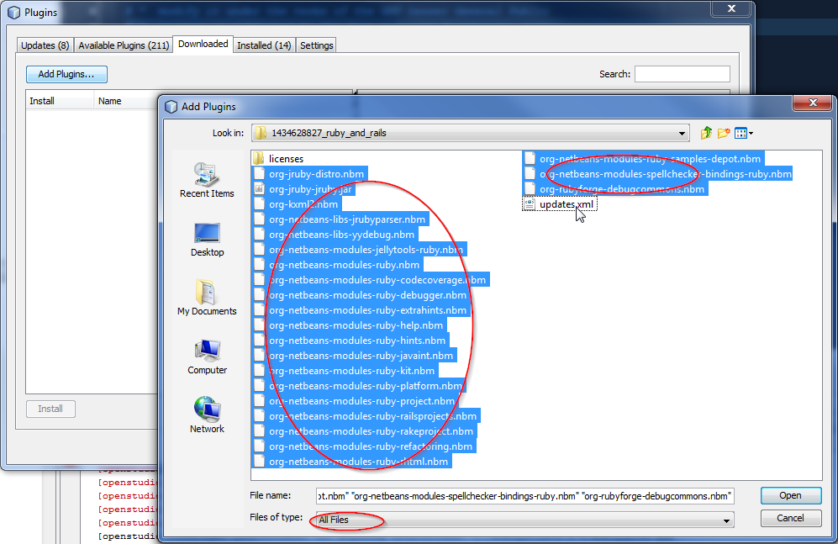

### Configure NetBeans for OpenStudio.

1. In NetBeans Open the project. File->OpenProject and navigate to the root folder of the project. Select “netbeans” and open it.

### 

1. Once the project is loaded, right-click on the BTAP root and go to Set Configuration->Customize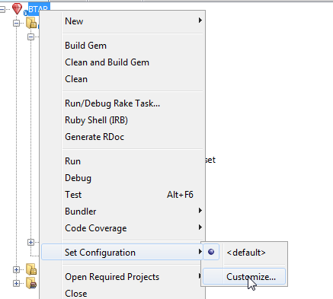
2. Click on Run and Manage

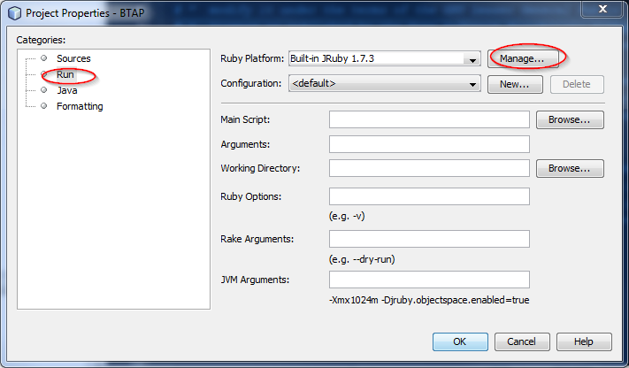

1. Click Add Platform

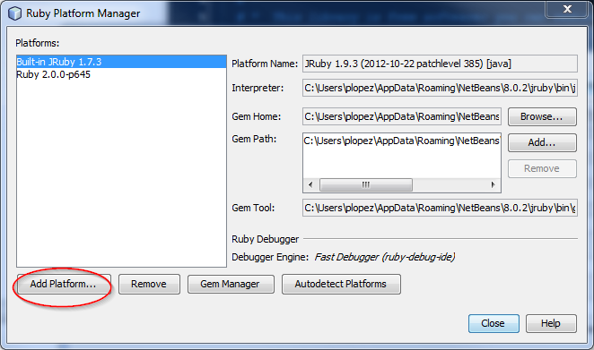

1. Navigate to your OpenStudio Installation’s ruby interpreter(ruby.exe).. For example version 1.8 is here “C:\Program Files\OpenStudio 1.8.0\ruby-install\ruby\bin”. Open the ruby.exe file.

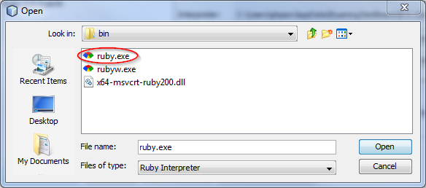

1. Select the OpenStudio Ruby as the default interpreter for Netbeans.

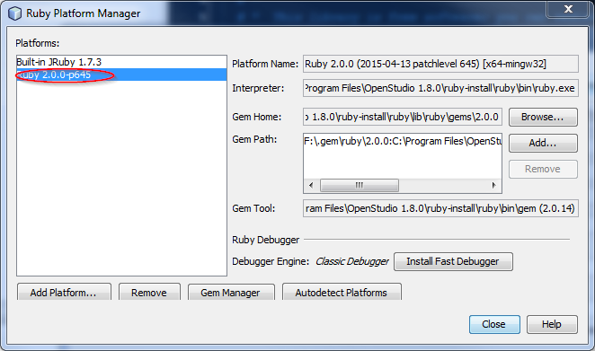

### Running the Simulations

1. Go to this path relative to the root of your cloned repository using windows explorer.

OpenStudio-Prototype-Buildings\lib\btap\measures\btap_campus_classic

1. Expand the xlxs data contained in the Excel file to csv file by running the PowerShell script on XLS2csv.ps1



1. In NetBeans open the btap_cold_lake_classic_test.rb file.

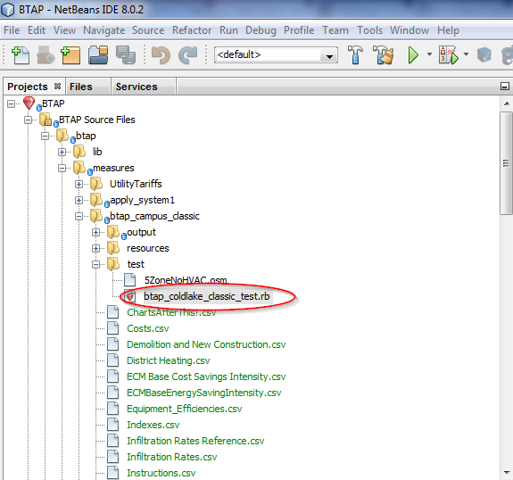

1. Right click on the file editor window and click run and click ok.

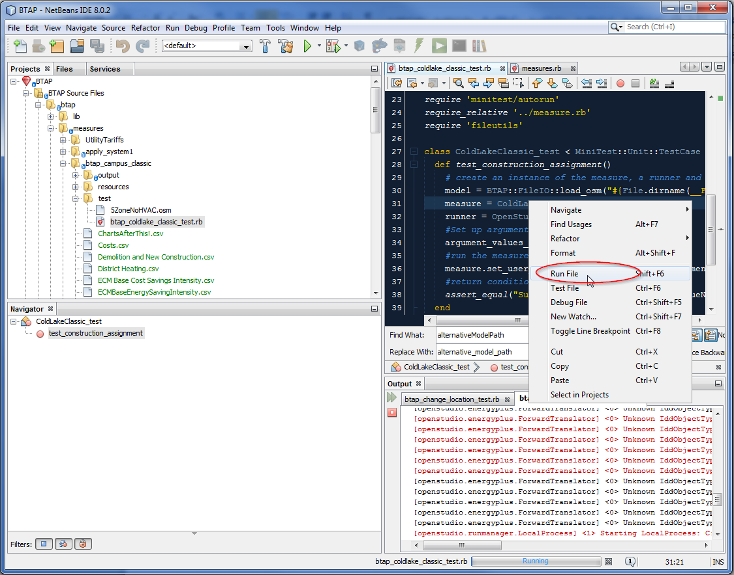

Now you should see things start. Depending on your computer this may take hours..or days. After all the files are created, it will start running them.. You should see this pop up in an hour or less. All output is contained in:

OpenStudio-Prototype-Buildings\lib\btap\measures\btap_campus_classic\output